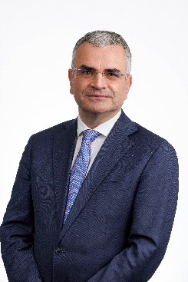
Message from Dara Calleary TD
Minister for Rural and Community Development and the Gaeltacht

Welcome to the 2025 Athlone Agricultural Show

As Minister for Rural and Community Development and the Gaeltacht, I am delighted to be in a position to support the Athlone Agricultural Show for 2025. My Department will again this year provided €1 million to over 120 other agricultural shows combined across the country, including your own event here in 2025.

Ní hamháin gur ceiliúradh ar shaol na tuaithe agus ar thraidisiúin na tuaithe iad seónna, is ceiliúradh freisin iad ar an nuálaíocht agus ar scoth na tuaithe. Déanann na seónna ceiliúradh freisin ar atá i gceist agus ar an tábhacht atá le Meitheal a bhfuil rath na bpobal seo ina croílár.

Like the show here in Athlone, each local show around the country continues to be a key social event in the agricultural calendar. They have so much to offer, not just in terms of the competitions that are taking place here today, but also for the platform they provide to local businesses, local farmers and for local craft and artisan food producers. The local show is also one of the best days of the year for meeting neighbors and friends.

Your local shows provide a great link between our towns and villages and the rural hinterlands that support them. A place where exhibitors, producers, farmers and the wider public meet face to face to share all that is good about life in the countryside.

Each of the shows taking place this year have something special that makes them stand out from the rest. It may be the pedigree livestock competitions or perhaps the exhibitions and food offerings. Whatever it is, your local agricultural show has something for everyone.

I would like to acknowledge the work that goes on for many months behind the scenes to bring this show to fruition. The efforts of committee members and local volunteers is a testament to how much this show means to the locality. Of course there is a sense of local rivalry for those much coveted titles and awards but it is always in the very best of spirits. The way in which neighbouring farms and parishes come together to support each other is a key component of country life. This sense of Meitheal is always on display as part of the local show.

Today is a chance to take a break from the busy farming schedule this time of year. I hope those of you attending the show this year thoroughly enjoy the day and that it gives everyone a chance to celebrate all that is good about rural Ireland. I will be visiting a number of the shows around the country and meeting as many of you as I can.

Dara Calleary TD
Minister for Rural and Community Development and the Gaeltacht

